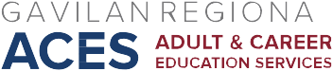

AB 104 Consortium Meeting
April 30, 2018
Agenda

- Approve March 16, 2018, minutes

- Vote on allocations

- Complete CFAD in NOVA and certify

Next Meeting: May 4, 2018, 2:30-4:30, ESL Computer Lab Conference Room

